Project Design Phase-II
Technology Stack (Architecture & Stack)

Date | 15 July 2026
Team ID
Project Name | Food Ordering Behaviour and Consumer Trends
Maximum Marks | 4 Marks

Technical Architecture:
The Deliverable shall include the architectural diagram as below and the information as per the table1 & table 2
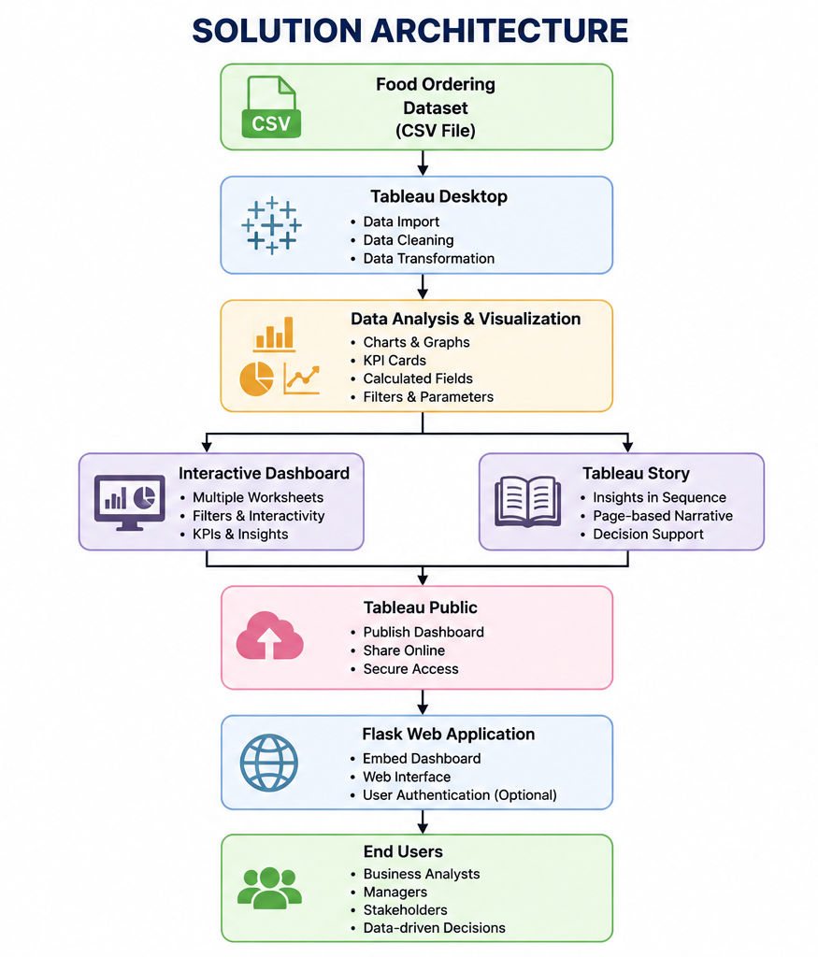
Table-1 : Components & Technologies:
S.No | Component | Description | Technology
 | User Interface | Interactive dashboard accessed through web browser | HTML, CSS, JavaScript
 | Application Logic-1 | Data cleaning and preprocessing | Python, Pandas
 | Application Logic-2 | Dashboard creation and visualization | Tableau Desktop
 | Application Logic-3 | Dashboard publishing and embedding | Tableau Public, Flask
 | Database | Structured food ordering dataset | CSV Dataset
 | Cloud Database | Dashboard hosting | Tableau Public
 | File Storage | Dataset and project files | Local File System
 | External API-1 | Dashboard embedding | —
 | External API-2 | Not Applicable | —
 | Machine Learning Model | Not Used | Object Recognition Model, etc.
 | Infrastructure (Server / Cloud) | Local development and cloud dashboard hosting | Local System + Tableau Public

Table-2: Application Characteristics:
S.No | Characteristics | Description | Technology
 | Open-Source Frameworks | Python libraries used for preprocessing | Python, Pandas
 | Security Implementations | Secure local data handling and Tableau Public access | Flask, HTTPS
 | Scalable Architecture | Modular architecture separating data processing, visualization, and deployment | Tableau + Flask
 | Availability | Dashboard available online through Tableau Public | Tableau Public
 | Performance | Optimized dashboard using filters, calculated fields, and efficient visualizations | Tableau Desktop

References:
https://c4model.com/
https://developer.ibm.com/patterns/online-order-processing-system-during-pandemic/
https://www.ibm.com/cloud/architecture
https://aws.amazon.com/architecture
https://medium.com/the-internal-startup/how-to-draw-useful-technical-architecture-diagrams-2d20c9fda90d

